**Problem 1:**

**SOURCE CODE:**

Training_center = [letters for letters in 'ACADGILD']

print(Training_center)

**OUTPUT:**

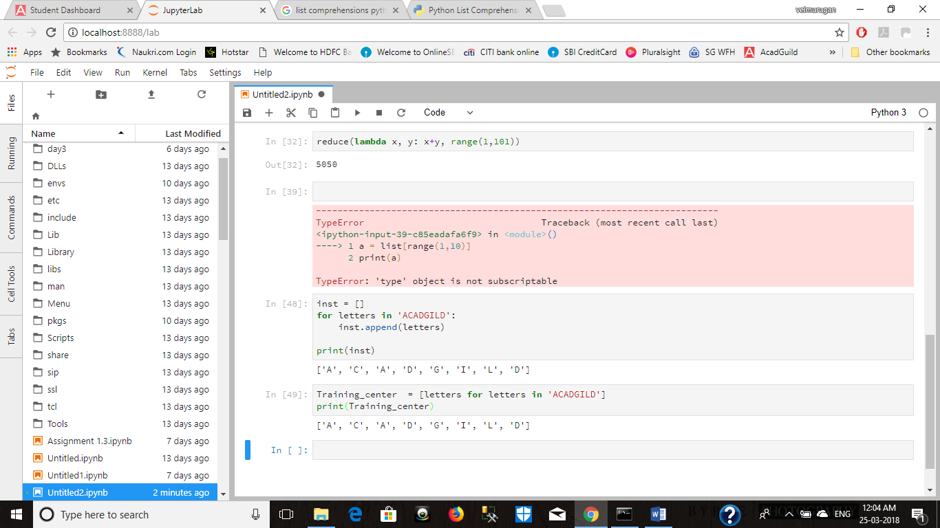

**Problem 2:**

**SOURCE CODE:**

data = ['x', 'y', 'z']

output = list(a*i for a in data for i in range(1,5))

print(output)

**OUTPUT:**

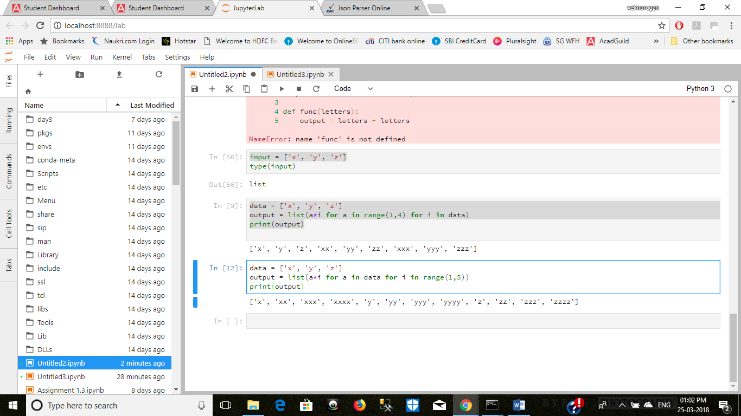

**Problem 3:**

**SOURCE CODE:**

data = ['x', 'y', 'z']

output = list(a*i for a in range(1,4) for i in data)

print(output)

**OUTPUT:**

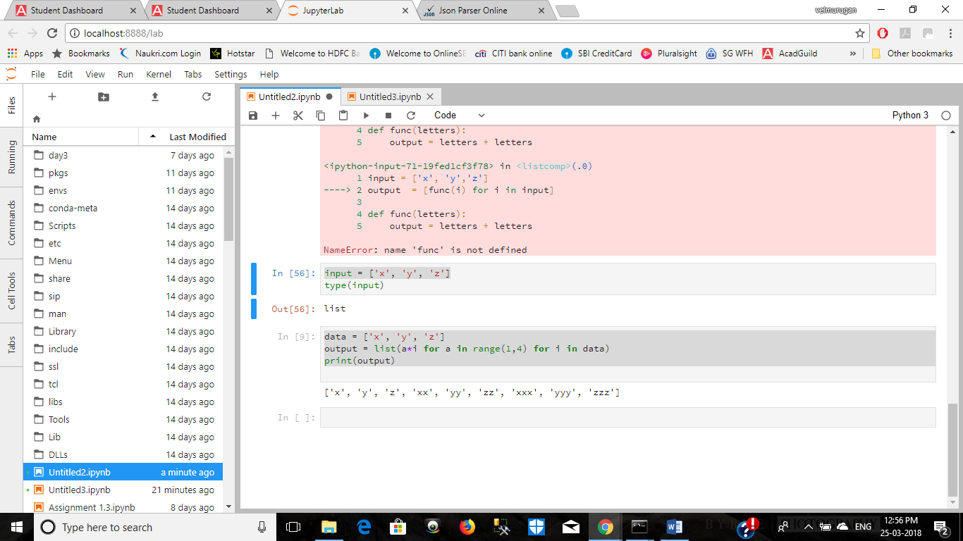

**Problem 4:**

**SOURCE CODE:**

output = []

output=list(a+i for a in range(1,4) for i in range (1,4))

print(output)

**OUTPUT:**

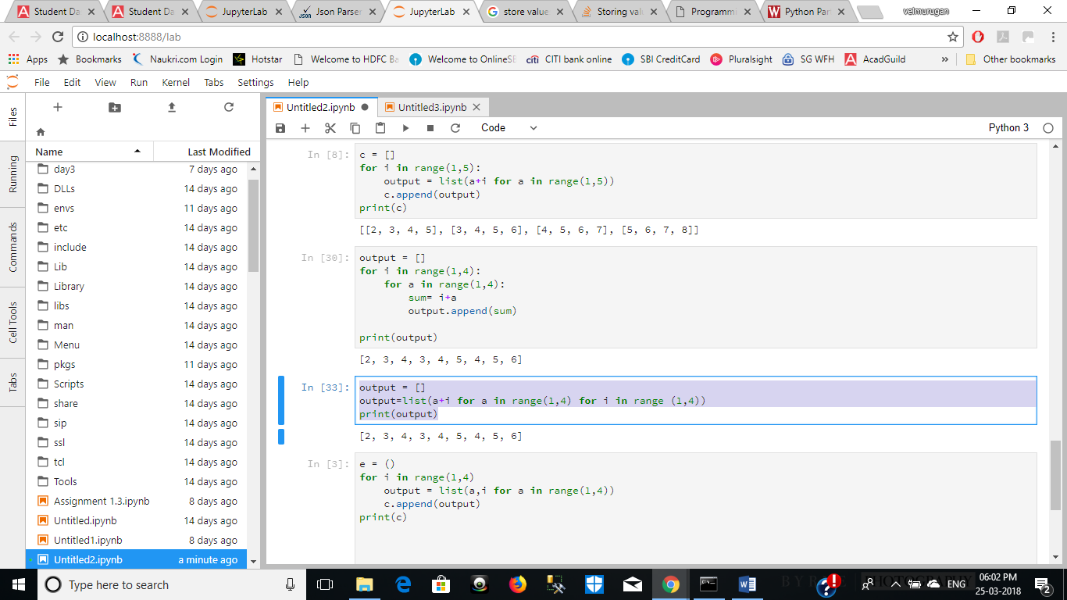

**Problem 5:**

**Source code:**

c = []

for i in range(1,5):

output = list(a+i for a in range(1,5))

c.append(output)

print(c)

**OUTPUT:**

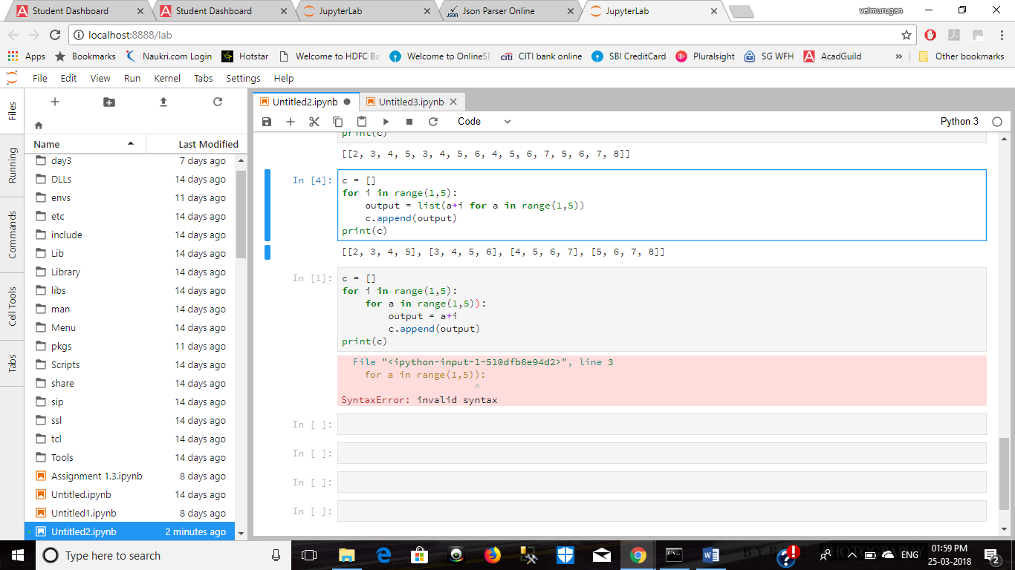

**Problem 6:**

**Source code:**

matrix = list((j,i) for i in range(1,4) for j in range(1,4))

print(matrix)

**OUTPUT:**

